Source https://bevacationtravels.com/product/denpasar-indonesia-sunset-at-uluwatu-kecak-dance-performance-and-dinner-at-jimbaran-beach/
__________________________________________________________

Bali Sunset Magic: Uluwatu Temple, Kecak Fire Dance & Jimbaran Beach Dinner
__________________________________________________________
★★★★★ 4.7/5 20 reviews

Add to wishlist ♡

__________________________________________________________

6 hours | €40 per person

🏕  Image | 🏕  Image | 🏕  Image | 🏕  Image | 🏕  Image | 🏕  Image

__________________________________________________________
About This Tour
Spend an unforgettable evening discovering Bali’s most captivating cultural and scenic highlights. This private experience takes you to the legendary Uluwatu Temple perched dramatically above the ocean, where you’ll watch the sunset paint the sky in golden hues. As twilight falls, enjoy the mesmerizing Kecak Fire Dance performed by over 50 chanting performers, bringing ancient legends to life.
The evening concludes with a delicious seafood dinner by the sea at Jimbaran Beach, offering a romantic and authentic Balinese atmosphere.
__________________________________________________________
What’s Waiting for You
- Duration: 6 hours
- Group Size: Private tour experience
- Languages Available: English
- Guide/Driver: English-speaking private driver
- Transportation: Hotel pickup & drop-off included
- Season: Available year-round
- Pickup Areas: Kuta, Legian, Seminyak, Canggu, Jimbaran, Nusa Dua, Sanur, Denpasar
__________________________________________________________

Check Dates & Availability

Select participants: (Age 99 and younger) - 1 +

Choose date:
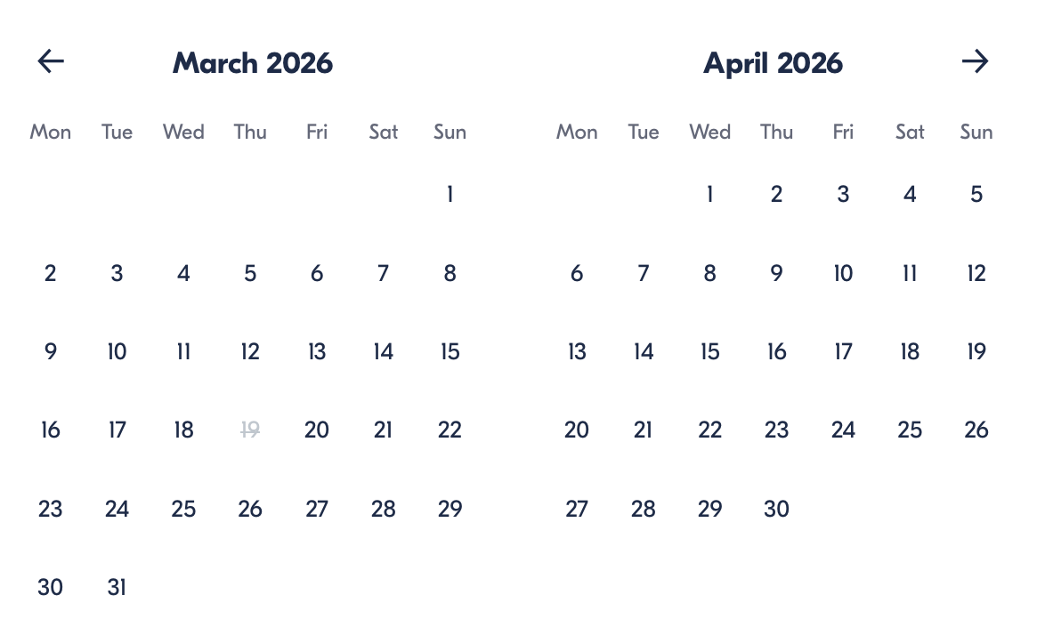

Check Availability

opens:

Participants: 1 March 16, 2026

Bali Sunset Magic: Uluwatu Temple, Kecak Fire Dance & Jimbaran Beach Dinner

- Start time: 3:00 PM

Cancellation:

- More than 24 hours before start — Full refund
- 24 hours or less before start — No refund

Price breakdown: 1 Participant x €40

Total: €40

The total price includes all taxes and fees.

Add to cart Book now

__________________________________________________________
Tour Features
- Uluwatu Temple Sunset: Watch the sun dip below the ocean from a dramatic cliff-top setting
- Kecak Fire Dance: Witness a traditional Balinese performance inspired by the Ramayana epic
- Jimbaran Beach Dinner: Enjoy fresh seafood in a scenic seaside setting
- Private Experience: Personalized journey with your own driver
- Seamless Transfers: Direct hotel pickup and drop-off
__________________________________________________________
Detailed Itinerary

Uluwatu Temple Visit
Begin your evening at one of Bali’s most iconic spiritual landmarks. Dating back to the 11th century, Uluwatu Temple is tied to the revered priest Mpu Kuturan, who helped unify Balinese spiritual traditions. Perched on a cliff high above the ocean, it offers breathtaking panoramic views — especially magical at sunset.

Kecak & Fire Dance Performance
As dusk settles, watch a captivating cultural show featuring around 50 performers chanting rhythmic “chak” sounds. This dramatic storytelling performance depicts scenes from the Ramayana, following Prince Rama’s quest to rescue his beloved Sita. The fiery spectacle and dramatic chants create a truly unforgettable atmosphere.

Jimbaran Beach Seafood Dinner
End your evening with a relaxing dinner along Jimbaran Beach. Enjoy a flavorful set menu featuring freshly caught seafood prepared using traditional recipes with subtle Western influences. With waves nearby and stars overhead, it’s a perfect finale to your Bali evening experience.
__________________________________________________________
Included in Price
- Private tour service
- Hotel pickup and drop-off
- English-speaking driver
- Entrance fees (if option selected)
- Kecak dance ticket (if option selected)
- Seafood dinner (if option selected)
- Service and government taxes
__________________________________________________________
Not Included
- Personal expenses
- Optional upgrades not selected at booking
__________________________________________________________
Who Should Avoid This Tour
- Wheelchair users
- Pregnant travelers
- Travelers with back problems
- Individuals with serious medical conditions, such as heart issues
__________________________________________________________
Important Trip Info
- Confirmation will be received at the time of booking
- Most travelers can participate
- This is a private tour — only your group will join
- Pickup times vary by location: 14:30 — Canggu; 15:00 — Sanur, Kuta, Legian, Seminyak; 15:30 — Jimbaran, Nusa Dua; 16:00 — Pecatu, Ungasan, Uluwatu
__________________________________________________________

Cancellation Policy
- More than 24 hours before start — Full refund
- 24 hours or less before start — No refund
__________________________________________________________
What Our Clients Are Saying

Overall rating  4.7/5  ★★★★★  Based on 20 reviews | Review summary  Guide 4.5/5  Transportation 4.6/5  Service 4.7/5  Organisation 4.5/5

Filter  - All traveller types  - Couples  - Group of friends  - Families  By star rating  - All star ratings  - 5 stars  - 4 stars  - 3 stars  - 2 stars  - 1 star | Search reviews (e.g., guide)  Sort by:  - Top picks  - Latest reviews  - Best ratings  - Lowest ratings
__________________________________________________________
★★★★★
Daniel R. — United States
The sunset and Kecak dance were absolutely magical. Dinner by the ocean made it perfect.
★★★★★
Lucia M. — Spain
Beautiful scenery, amazing performance, and delicious seafood. A perfect Bali evening.
★★★★★
Olivia T. — Australia
Everything was seamless and well organized. The cultural show was unforgettable.
★★★★★
Carlos S. — Spain
Romantic, scenic, and authentic. Highly recommend for couples.
★★★★★
Kenji W. — Japan
One of the highlights of my trip. Incredible views and great atmosphere.
See more reviews
__________________________________________________________

Meta tags

Page - Bali Sunset Magic: Uluwatu Temple, Kecak Fire Dance & Jimbaran Beach Dinner

Title: Bali Sunset Magic: Uluwatu Temple, Kecak Fire Dance & Jimbaran Beach Dinner | Travellio Global

Description: Experience Bali’s magic with a sunset at Uluwatu Temple, a traditional Kecak fire dance performance, and a seafood dinner on Jimbaran Beach. Private tour with transfers included.

H1 - Bali Sunset Magic: Uluwatu Temple, Kecak Fire Dance & Jimbaran Beach Dinner
__________________________________________________________

